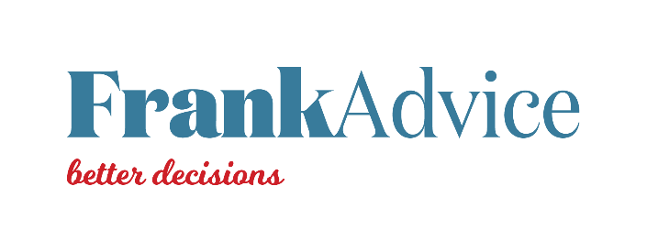

A learning system for addressing persistent disadvantage

A learning system for addressing persistent disadvantage

A learning system for addressing persistent disadvantage

A learning system for addressing persistent disadvantage

Productivity Commission

February 2023

Productivity Commission

February 2023

Productivity Commission

February 2023

Productivity Commission

February 2023

frankadvice.co.nz

frankadvice.co.nz

frankadvice.co.nz

frankadvice.co.nz

frankadvice.co.nz

frankadvice.co.nz

frankadvice.co.nz

frankadvice.co.nz

frankadvice.co.nz

frankadvice.co.nz

frankadvice.co.nz

frankadvice.co.nz

frankadvice.co.nz

frankadvice.co.nz

frankadvice.co.nz

frankadvice.co.nz

Contents
Executive summary 3
Background and context 5
The Productivity Commission inquiry interim report – A fair chance for all: Breaking the cycle of persistent disadvantage 5
What are the current problems with the public management system’s ability to learn? 6
What does ‘learning system’ mean? 6
What would good look like for a learning system? 7
A learning system could help overcome public management system barriers by supporting four key shifts 7
A learning system must embody different values to help effectively address persistent disadvantage 8
A learning system must give effect to Te Tiriti o Waitangi 10
Outline of the current report 11
Conceptual approach to the project 13
We have used the concept of ‘knowledge’ rather than ‘evidence’ 13
We have taken a temporal approach: hindsight, insight, foresight 14
We scanned for literature relevant to a learning system 15
We used knowledge gathered from the key thinkers workshop as well as case studies to structure our approach 16
Key players in a learning system 18
Key components of a learning system and their current state 23
Knowledge generation 23
Knowledge use 23
Leadership 24
Accountability 24
Capability 25
Capacity 25
Potential actions to set in place a learning system 26
Illustrating the actions that will strengthen knowledge generation and knowledge use 34
Illustrating the actions that will strengthen leadership and accountability 41
Illustrating the actions that will strengthen capability and capacity 46
Summary of potential actions 48
Appendix 1: Key thinkers workshop – attendees and questions discussed 52
Appendix 2: Bibliography 54

Executive summary
The Productivity Commission is conducting an inquiry – A fair chance for all: Breaking the cycle of persistent disadvantage – which produced an interim report in September 2022. The interim report included commentary on the need for leadership and stewardship for system learning and improvement in the public management system (a ‘learning system’).

The Productivity Commission has engaged FrankAdvice to carry out a project to prepare a report setting out potential features of a learning system. The Productivity Commission intends to use this work to inform their findings and recommendations in relation to a stronger public management learning system.

As part of the project, FrankAdvice gathered knowledge through a range of approaches, including a partnership with the Productivity Commission to run a key thinkers workshop. This report distils the results of this knowledge gathering.

The report considers what ‘learning system’ means, and what a good learning system might look like, before discussing the conceptual and other aspects of our approach to the project. It then sets out:
- the key players in a learning system (both within and outside the Crown)
- the key components of a learning system (what would need to be in place for a learning system to be effective), and their current state
- a mapping of the status quo against the key components of a learning system, so we can see where the gaps are, and the actions that would be needed to address them.

We conclude with a detailed discussion of the actions we believe are needed to establish a learning system with all the necessary components.

This report is intended to be an input into wider work by the Productivity Commission, stemming from its inquiry. Rather than a comprehensive work of research, it should be read as a bringing together of expertise from key thinkers and case studies, supplemented by a scan of relevant literature from Aotearoa New Zealand and overseas, and the authors’ analysis.

FrankAdvice thanks Sally Washington and ANZSOG for their review of this work as well as all other participants who provided their time across this project.

Background and context

The Productivity Commission inquiry interim report – A fair chance for all: Breaking the cycle of persistent disadvantage
The Productivity Commission is conducting an inquiry – A fair chance for all: Breaking the cycle of persistent disadvantage. The inquiry is looking into “economic inclusion and social mobility, focusing on the drivers and underlying dynamics of persistent disadvantage” (New Zealand Productivity Commission, 2022, p. ii). The interim report for the inquiry (the interim report) was published in September 2022.

As part of the inquiry process, the Productivity Commission looked at the role of the public management system in addressing persistent disadvantage. It identified that for the public management system to more effectively address persistent disadvantage, the system must be able to learn and improve – that is, it must be a ‘learning system’. While the interim report did not fully elaborate the concept of a learning system, it made two related findings and a recommendation:
- Finding 6.21: Leadership and stewardship for system learning and improvement in the public management system is missing, and the situation appears worse than when the [Productivity] Commission reviewed the effectiveness of social services in 2015 (p. 103)
- Recommendation 6.9: An all-of-government system functional lead role should be designated for system learning and improvement (p. 103).
- Finding 6.22: Monitoring and evaluation practices need to adapt in the face of complex systems. They should be about enabling continuous learning as much as they are an accountability tool. The role of evaluators should also be re-assessed. They should be seen more as ‘critical friends’ than external auditors (p. 104).

The Productivity Commission engaged FrankAdvice to prepare a separate report that sets out potential features of a learning system (this report). The Productivity Commission intends to use this work to inform their findings and recommendations in relation to a stronger public management learning system. These findings and recommendations will inform the Productivity Commission’s final report, to be tabled with Ministers in May 2023. A more detailed explanation of the current project is provided in later sections.

What are the current problems with the public management system’s ability to learn?
In this report, we take the definition of ‘public management system’ used in the interim report:
- the (evolving) set of institutions within government, and their functions and mandates
- the policymaking process; and the public policy settings (e.g., legislation, regulations and non-statutory frameworks) that are created and maintained by the public service
- system-wide governance, accountability and funding arrangements
- how the public service works together through relationships and partnership to deliver results for Ministers and the public, including for specific populations.

(New Zealand Productivity Commission, 2022, p. 13)

The public management system contains four main barriers that inhibit its ability to address persistent disadvantage: power imbalances; discrimination and the ongoing impact of colonisation; siloed and fragmented government; and short-termism and status quo bias (New Zealand Productivity Commission, 2022, p. 5). These barriers mean it does not always learn about what is needed to address persistent disadvantage.

Specific issues include:
- little demand for monitoring, evaluation research and learning (MERL), sometimes due to a fear of exposing failure
- limited capability to undertake evaluation
- evaluation at the level of funders (central government), far from the people doing the work being evaluated
- evaluation showing outcomes a long time after an actual intervention, so the people doing the work do not have timely access to the knowledge they need to learn and improve.

What does ‘learning system’ mean?
A public management system is a learning system when it learns about, understands how to do, then makes sure it does the right actions – in this case, the actions needed to address persistent disadvantage. That means it must help the public management system to transform the ways in which it works to address persistent disadvantage. To achieve this, the learning system itself must transform – i.e., it must actually act as a system, rather than continue to act as isolated components, with gaps between those components. It should be purposefully designed, not left to chance.

A functioning learning system will gather the right knowledge to help the public management system understand what does and does not work for whom, inform decisions, and track progress over time. It will be guided by values, using a strengths-based approach, rather than looking at people experiencing persistent disadvantage through a deficiency lens.

While there is no consensus on what ‘learning system’ means – a point we will return to – we find it helpful to look at Canada’s monitoring and evaluation system for an outline of the potential elements of a learning system (Lahey & Nielsen, 2013). These are:
- leadership by a (central) agency
- a government-wide evaluation policy
- issuing of requirements and standards of practice
- requirements on departments to dedicate resourcing to evaluation
- a (separate) centre of excellence
- the (central) agency ensures compliance.

All of these elements are discussed in this report, although sometimes with different terminology, with other elements also proposed. We note that overseas models cannot be uncritically adopted here, because our own learning system must give effect to Te Tiriti o Waitangi and indigenous values, recognising Aotearoa’s specific context.

What would good look like for a learning system?

A learning system could help overcome public management system barriers by supporting four key shifts
An effective learning system – one that helps the public management system better address persistent disadvantage – would need to overcome the four barriers described above, and the ways these barriers inhibit the system from learning. The interim report articulates a set of system shifts required to overcome these barriers:
- re-think overall system settings to prioritise equity, wellbeing and social inclusion
- re-focus public accountability settings to activate a wellbeing approach
- broaden and embed a wellbeing approach across policymaking and funding frameworks
- enable system learning and improvement through monitoring and evaluation
(New Zealand Productivity Commission, 2022, p. 76)

This project relates most directly to the fourth shift, but the other shifts also suggest the direction for a learning system. Looking across all the shifts, we can identify that a learning system should include the following strengths:
- sharing and synthesising knowledge across the public management system, with policies and mechanisms in place to ensure this happens – so a repository of ‘what works’ for addressing persistent disadvantage is built up
- including diverse views and perspectives, which would involve engaging people who are affected by government decisions, so they help shape those decisions as well as judge the impacts
- helping policymakers take decisions that work, now and in the future, to improve the lives of people experiencing persistent disadvantage and advance equity
- taking an intergenerational lens, which includes ensuring the impacts of decisions over time are evaluated (Washington, Productivity Commission peer review with ANZSOG template: Draft report: a learning system for addressing persistent disadvantage, 2022).

A learning system must embody different values to help effectively address persistent disadvantage
The effectiveness of a learning system will rest not just on what it does, but how it does it. To be transformative, it will need to embed a fundamentally different set of values – a point emphasised by the interim report. The inquiry has derived its conceptual framework from indigenous values, such as those expressed in He Ara Waiora and the Pacific Wellbeing Strategy. These values are set out in the table below.

Table 1: Values of He Ara Waiora and the Pacific Wellbeing Strategy, as they appear in the interim report (New Zealand Productivity Commission, 2022, p. 23)
He Ara Waiora means (or values) | Pacific Wellbeing Strategy values
Kotahitanga (unity) | Piri’anga (collectivism)  Ola fetufaaki (reciprocity)
Whanaungatanga (relationships) | Magafaoa (family)
Manaakitanga (care and respect) | Aro’a (love)  Fakalilifu (respect)  Ola fetufaaki (reciprocity)
Tikanga (protocol) | Soalaupule (consensus)
Tiakitanga (guardianship or stewardship) | Tāpuakiga (spirituality)  Ola fetufaaki (reciprocity)

Drawing particularly on comments by participants in the key thinkers workshop (described further below), we consider that when these values are truly embedded in a public management learning system, this is what we would see.
- Kotahitanga (unity): The learning system takes a genuine system view. This unity requires leadership, and alignment of all the actors and components within the system.
- Whanaungatanga (relationships): The learning system builds and maintains positive, meaningful and reciprocal relationships, both within the learning system and between the learning system and communities (especially those experiencing persistent disadvantage).
- Manaakitanga (care and respect): People and communities are at the heart of the learning system. The learning system should embody a deep ‘ethic of care’ for people experiencing persistent disadvantage; especially because they are underserved by the current public management system.
- Tikanga (protocol): Using appropriate tikanga and processes will mean the learning system has the right people using the right approaches to make the right decisions. The learning system is based in a broader idea of what counts as evidence – working instead with knowledge – and makes better use of knowledge.
- Tiakitanga (guardianship or stewardship): To demonstrate tiakitanga, the learning system must prompt the public management system to move beyond its current narrow focus on traditional indicators of success such as economic growth. Concepts of intergenerational wellbeing are critical to stewardship.

In the sections that follow the components of a learning system, and the actions suggested to give effect to those components, are intended to realise the values (means) of He Ara Waiora. We see the values as having broad resonance for Aotearoa New Zealand, including the different groups who are overrepresented in the experience of persistent disadvantage.

To be successful, a learning system would need to demonstrate in a measurable way that it is upholding its values. This might entail co-defining with communities and experts the appropriate ways to measure whether the values have been embedded, then monitoring accordingly.

A learning system must give effect to Te Tiriti o Waitangi
The interim report states that, to address persistent disadvantage, “[n]ew values must be grounded in te ao Māori in recognition of Te Tiriti o Waitangi (Te Tiriti) as the foundational document of Aotearoa New Zealand” (New Zealand Productivity Commission, 2022, p. 1). The interim report also describes how, “our systems and social safety net do not meet the needs of people and communities with multiple complex needs facing persistent disadvantage. And despite the Crown’s obligations under Te Tiriti o Waitangi, they fail to provide equitable outcomes for Māori” (New Zealand Productivity Commission, 2022, p. i).

Submitters to the inquiry observed that the failure of the Crown to honour Te Tiriti o Waitangi has meant ongoing impacts of colonisation contribute to greater persistent disadvantage for Māori.

An effective learning system must help remedy these failures and help the public management system give effect to Te Tiriti o Waitangi.

Outline of the current report
The scope of this report is based on the following five questions, determined by the Productivity Commission.
- What are the [public management system] learning system settings and components that New Zealand would need to address complex problems like persistent disadvantage?
- How would this system overcome the four barriers and support the system shifts identified in the A fair chance for all: Breaking the cycle of persistent disadvantage interim report?
- What system settings and components already exist in New Zealand that are working well? What is missing or needs to be improved?
- How might te ao Māori values influence the design of the learning system settings and components?
- What are some of the concrete steps that can be taken to realise the new settings and components and how could we ensure they are adapted over time?
Out of scope are constitutional issues, Budget and legislative processes, and accountability mechanisms. This means that while this report suggests areas in which accountabilities might be appropriate, it does not consider the specific mechanisms required to enact those accountabilities.

To gather the knowledge required for this project, we:
- ran, with the Productivity Commission, a workshop with key thinkers in areas relevant to a learning system
- scanned selected academic and grey literature, from Aotearoa New Zealand and overseas
- looked at potential examples and case studies of initiatives that could inform a learning system
- had iterative discussions with Productivity Commission staff
- presented and discussed our emerging findings at a sense-making session with the Productivity Commission
- looked at a summary of submissions to the inquiry
- tested the findings of the project in interviews with selected key individuals, and sought the input of Te Atawhai Tibble on embedding Te Tiriti o Waitangi and te ao Māori in the work.

The key thinkers workshop was held on 22 November 2022 at the Productivity Commission. Attendees were a group of experts in areas related to the learning system, from both within and outside government, supported by Productivity Commission staff, FrankAdvice, and two independent facilitators. Expert attendees are set out in the following table.

Table 2: Expert attendees at key thinkers workshop
Expert attendee | Role and affiliation
Juliet Gerrard | Prime Minister’s Chief Science Advisor
Andrew Webber | Chief Economist, Social Wellbeing Agency
Alex Brunt | Deputy Chief Executive, Social Wellbeing Agency
Sankar Ramasamy | Chief Evaluator, Education Review Office
Penny Hagen | The Southern Initiative / Auckland Council
Graham Scott | Former Secretary of the Treasury
Claudia Scott | Emeritus Professor, School of Government, Victoria University of Wellington
Hugh Webb | Child Wellbeing and Poverty Reduction Group, Department of the Prime Minister and Cabinet
Emma Powell | Te Puna Aonui
Steve Murray | Evidence Centre, Oranga Tamariki
James McIlraith | Evidence Centre, Oranga Tamariki
David Stuart | Ministry of Culture and Heritage
Josh Palmer | Te Puni Kōkiri
Claire Bretherton | Te Puni Kōkiri
Nan (Ngahorihori) Wehipeihana | Kinnect

Conceptual approach to the project
The design of a learning system is a conceptually challenging task, because of the many angles, elements, and players involved. It may entail focusing on specific questions (for example: what evaluation methodologies should be used in a particular situation?) all the way through to broad considerations, such as the impact of colonialism on institutions in the public management system.

In this section we briefly discuss some of main ideas we have drawn on throughout this project, and how we have brought them together.

We have used the concept of ‘knowledge’ rather than ‘evidence’
Feedback from the key thinkers workshop urged a broader understanding of what counts as ‘evidence’. Communities need to play a role in determining what is important (and what therefore counts as evidence), and what is deemed important needs to go beyond traditional success indicators like economic growth.

One model recommended to us for understanding the breadth of evidence that could be used by a learning system is set out in the report Navigating the crisis: how governments used intelligence for decision making during the COVID-19 pandemic (Mulgan, Marsh, & Henggeler, 2022). Using the word ‘intelligence’ rather than ‘evidence’, the authors ‘define intelligence broadly to include data, evidence, models, tacit knowledge, foresight, and creativity and innovation – all the means that can help governments make better decisions, particular under conditions of stress and uncertainty’ (Mulgan, Marsh, & Henggeler, 2022, p. 6).

While we use the term ‘knowledge’, discussed further below, rather than ‘intelligence’, we agree with the fundamental point made by Mulgan, Marsh & Henggeler, that many different forms of information can feed into decision-making. The authors bring these forms of information together in a diagram as follows.

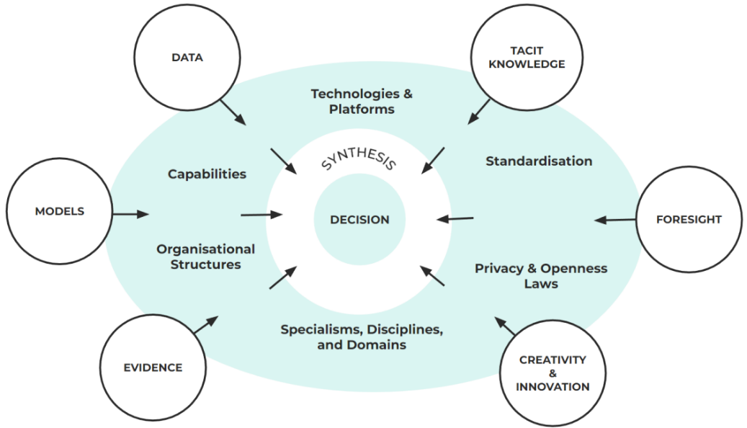
Figure 1: Types of intelligence are mediated and shaped by processes and contextual factors before feeding into decisions’ (Mulgan, Marsh, & Henggeler, 2022, p. 6)

We see value in Mulgan, Marsh, & Henggeler’s (2022) approach, but note that any learning system in Aotearoa New Zealand must include kaupapa Māori and mātauranga Māori, in addition to the forms of intelligence outlined above. A sense-making session with the Productivity Commission reiterated that the prevailing concept of ’evidence' is narrow, and can serve to exclude indigenous knowledge, so the term ‘knowledge’ is preferred. We use the term ‘knowledge’ here, and return to it later in this report.

We have taken a temporal approach: hindsight, insight, foresight
As noted above, short-termism and status quo bias are a barrier to addressing persistent disadvantage within the public management system (New Zealand Productivity Commission, 2022, p. 5). They inhibit the ability of the public management system to think and act over intergenerational timeframes, which is critical to stewardship. To overcome short-termism and status quo bias, the interim report calls for anticipatory governance and policymaking (New Zealand Productivity Commission, 2022, pp. 95-97).

To think about the temporal elements of policymaking, we have drawn on work by the Australia New Zealand School of Government (ANZSOG), which sets out three lenses: hindsight, insight and foresight (Washington, 2022 b). Using the three lenses, we can see the relationship between learning from the past to generate insights in the present, then projecting (and committing to evaluate) the future outcomes of decisions. In the discussion that follows, particularly in relation to Statistics New Zealand’s Integrated Data Infrastructure (IDI), we consider how the components of a learning system could reflect the three lenses.

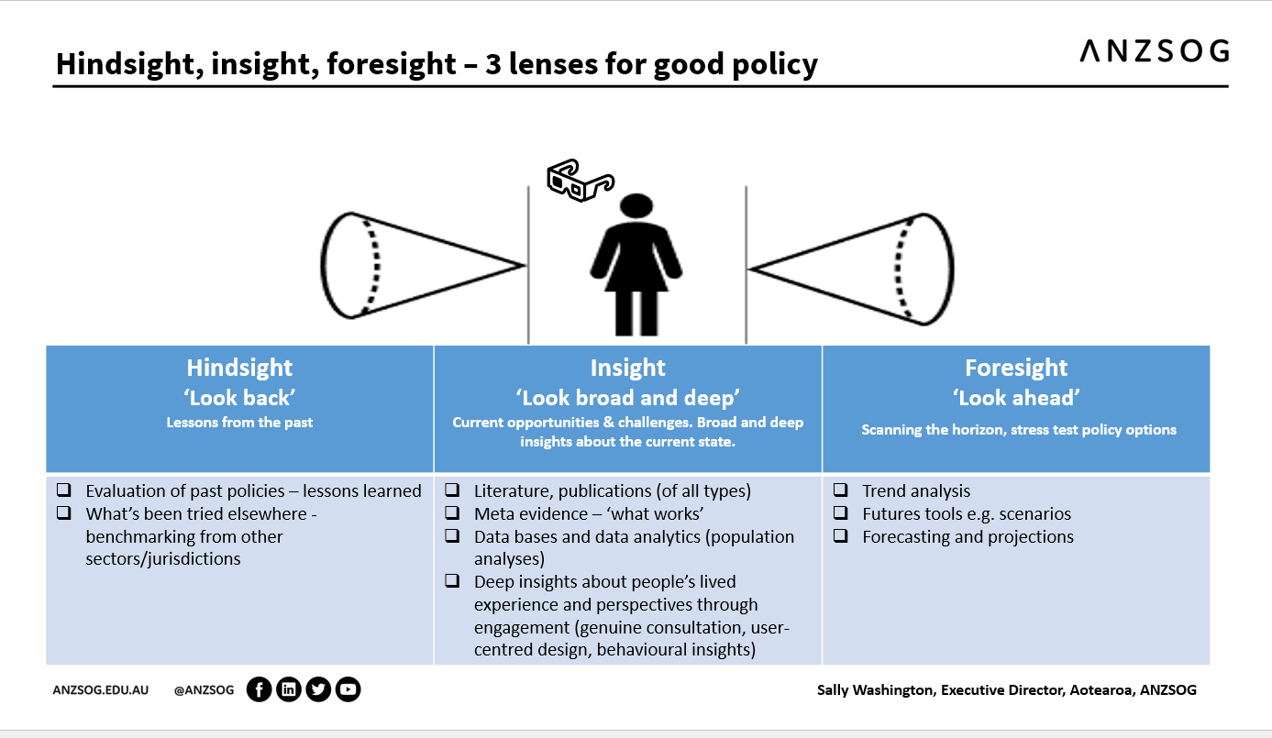
Figure 2: Hindsight, insight, foresight – 3 lenses for good policy (Washington, 2022 b)

Note that using anticipatory approaches means more than ensuring policy decisions take a long-term view, and that a learning system provides the knowledge to enable this. It means there is also a role for theory and futures thinking in a learning system – i.e., a learning system should help policymakers set out what they expect to see in future, anticipate scenarios and consider potential interventions through a futures lens. In this way, anticipatory approaches can help judge the intergenerational effectiveness of the public management system in addressing persistent disadvantage.

We scanned for literature relevant to a learning system
In scanning for literature on a learning system, we made two main observations.

The first observation is that the international literature has limited application in considering how to develop a learning system for Aotearoa New Zealand. We found relatively few international examples of learning systems we could draw on. This was partly because the term ‘learning system’ is not universally used. Nor did learning systems contain the same components as one another, meaning they were not necessarily comparable (for example, some covered only one area of government activity, such as a country’s education system).

International examples of potential interest include government evaluation systems emerging in Benin, Uganda and South Africa, and being considered in other African countries (Goldman, et al., 2018); and the mixed success of a national monitoring and evaluation approach in India (Gayithri, 2019). Canada’s monitoring and evaluation system has the greatest potential relevance for Aotearoa New Zealand. We used it to think about the potential components of the learning system, and the actions needed to fulfil those components – while noting that overseas models cannot be uncritically adopted here, because our own learning system must give effect to Te Tiriti o Waitangi and indigenous values.

Our second observation is that most literature relevant to a learning system tends to focus on particular components of a learning system, rather than taking a whole-of-system perspective. In most cases – for example, the component of knowledge generation – the literature is well-established and very large, and it was beyond the scope of the project to provide an overview.

We used knowledge gathered from the key thinkers workshop as well as case studies to structure our approach
Because the literature on international learning systems had limited application, and because there is already a wealth of literature on the components of a potential learning system, we focused most of our attention on gathering knowledge that is both novel (not already well-rehearsed in the literature) and applicable to Aotearoa New Zealand.

This was in keeping with one observation from the workshop: the greatest challenge in creating a learning system is not in knowing what to do – there was good alignment on this – but rather, in making sure people and organisations actually do it. The workshop showed that most potential features of a learning system are backed up with a strong knowledge base, and generally agreed on.

With this in mind, we took knowledge gathered through the workshop as our primary information source, because it built on already-established areas with original and practical insights. Participants at the workshop were asked a series of broad questions, allowing them to give free-flowing feedback on the issues they considered most important (details of the workshop are provided at Appendix 1). By analysing the workshop material, supplemented with our scan of the literature and our own thinking, we were able to distil the:
- key players in a learning system
- components of a learning system
- actions required to deliver those components.

To evidence our findings, we have used examples and case studies in this report, many of which were suggested by workshop participants.

We also looked at a summary of submissions to the inquiry. While submitters tended to focus less on the learning system than other aspects of the interim report, we have reflected their suggestions about potential leadership of a learning system.

Key players in a learning system
We began our analytic process by drawing on the interim report to map out the key players in a learning system.

Key player | Description
The people experiencing persistent disadvantage | 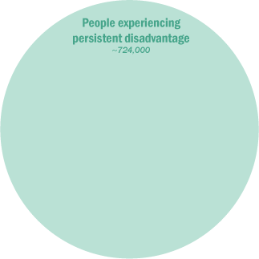  This is the group of people currently experiencing persistent disadvantage in Aotearoa New Zealand. Acknowledging the complexity of defining persistent disadvantage and current data issues, there are estimated to be approximately 724,000 people currently experiencing persistent disadvantage in New Zealand.
Tangata whenua | 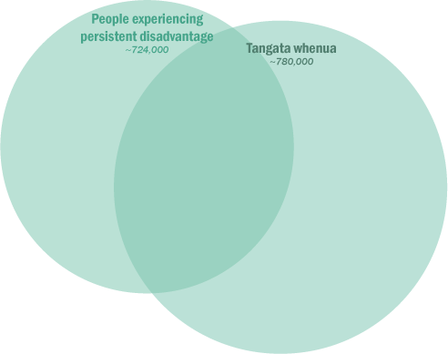  Tangata whenua are the indigenous people of Aotearoa New Zealand (current population of approximately 780,000). The government (and therefore the public management system and the learning system) have specific obligations to tangata whenua to honour Te Tiriti o Waitangi commitments and address imbalances between tangata whenua and tangata Tiriti.  As described in the interim report, tangata whenua are more likely than the “average” New Zealand population to experience persistent disadvantage, meaning there is a significant overlap between the people experiencing persistent disadvantage and tangata whenua.
The general public | 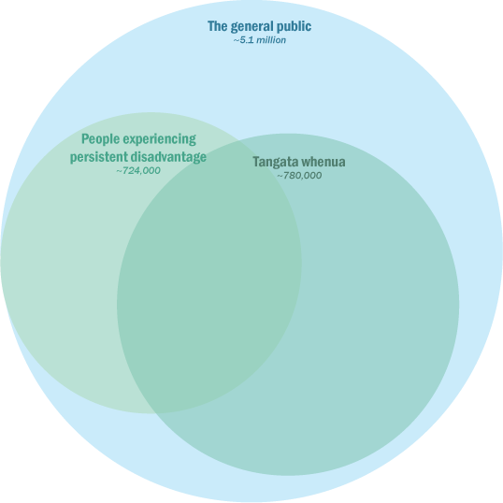  The general public represents all people currently living in New Zealand (current population of approximately 5.1 million). While most are not currently experiencing persistent disadvantage, they can move into that group at any time – and will receive services regardless – so will be affected by the actions of the learning system.
Future generations | Future generations represents all future inhabitants of Aotearoa New Zealand, including those who will experience persistent disadvantage in the future. Including them explicitly as a key player in the learning system emphasises the need for the system to consider their needs and demonstrate intergenerational stewardship.
The Crown | The Crown includes the executive (Ministers, including Ministers outside of Cabinet), central government (government departments), and local government. The agencies highlighted here are those potentially most relevant to the learning system and are not comprehensive.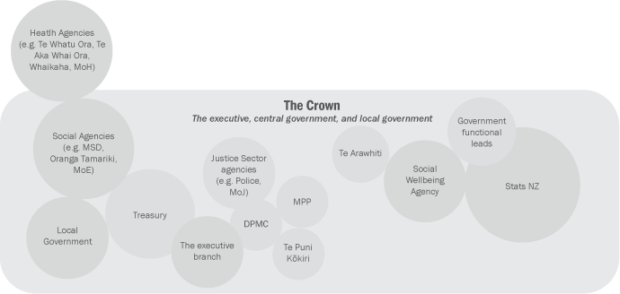
Providers | 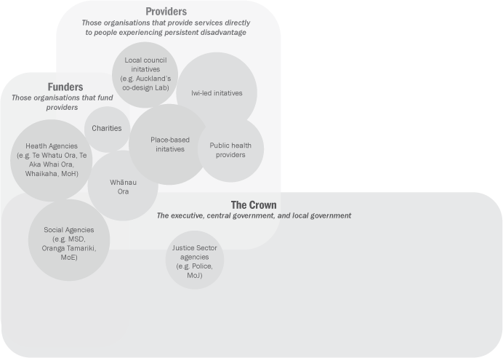  Providers are those organisations that provide services, and specifically provide services to those experiencing persistent disadvantage. These providers may be part of the Crown, funded by the Crown, or independent. Again, the providers highlighted here are those potentially most relevant to the learning system and are not comprehensive.
Funders | 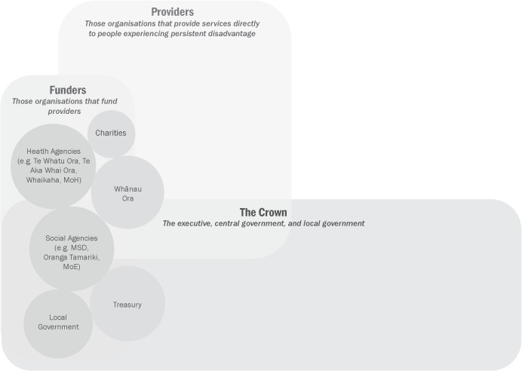  Funders are those organisations that fund providers. These funders will mostly be part of the Crown, but some are independent. There is also an overlap between funders and providers – sometimes the same organisation will have both roles. Again, the funders highlighted here are those potentially most relevant to the learning system and are not comprehensive.
Tertiary education providers and research institutes | Tertiary education providers and research institutes are institutions such as universities, polytechnics, wānanga, think-tanks, independent researchers, and training providers. While not part of the public management system, they are invaluable and independent sources of research, evidence, and capability and capacity development for the learning system.

These key players are brought together in the diagram on the following page.

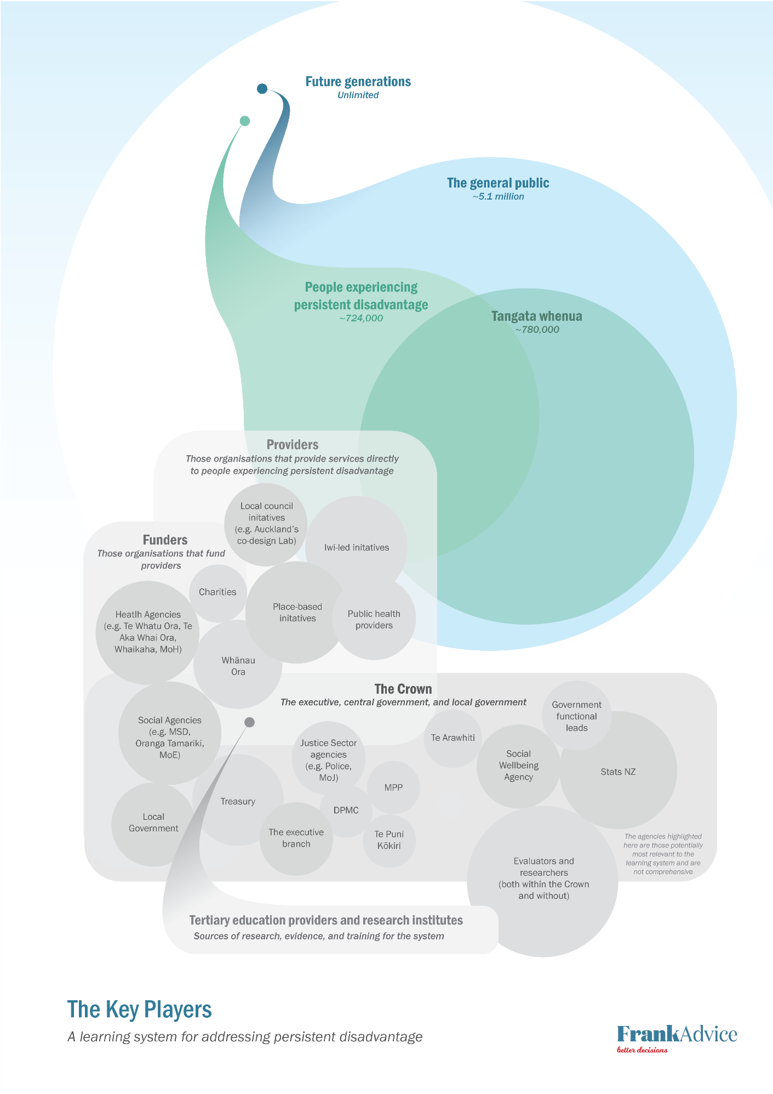
Figure 3: The key players diagram

Key components of a learning system and their current state
Our analysis identified six key components of an effective learning system:
- knowledge generation
- knowledge use
- leadership
- accountability
- capability
- capacity.

In the remainder of this section, we step through each of these necessary components and explain why it is important.

Knowledge generation
The knowledge generation component of a learning system reflects the importance of a learning system in determining ‘what works’. Critically, in learning what works, we should have a broad understanding of what ‘knowledge’ is: drawing not just on MERL approaches, but also seeking more extensively the voices of those who will be affected by a decision, or who are using the service or programme being evaluated.

Taking this broad understanding of knowledge is important because it supports a move away from conventional success measures like GDP, and is more open to indigenous knowledge and the voices of people. Research and evaluation are, however, an important part of knowledge generation, particularly evaluations that take a strengths-based approach, make widespread use of kaupapa Māori approaches, use collaborative methods that involve the communities that use the services being evaluated, and have an intergenerational and systems-based approach.

Many of the gaps in knowledge generation fall to the Crown to address. Currently, the Crown does not always employ a broad understanding of knowledge (instead, narrower concepts of ‘evidence’ may predominate), strengths-based approaches are infrequent, and evidence can be poorly synthesised. There can be insufficient collaborative evaluation, including with people experiencing persistent disadvantage, and insufficient use of kaupapa Māori or other methods driven by Māori.

Knowledge use
Knowledge use is the next component of an effective learning system. Knowledge use involves several steps. Once a broad range of knowledge is determined, that knowledge should be used in advice for decision makers, and service design and delivery. As well as being generated and used by government agencies, it also needs to be shared – both across government and with communities.

Currently, the different steps of knowledge use are not consistently carried out. Knowledge may not be flowed into advice for decision makers, or used to create timely improvements to service design and delivery. There can be a lack of knowledge sharing between and beyond government agencies, and the knowledge that is shared may not be accessible. This means funders do not have sufficient opportunity to improve their evidence-based decision-making and flow it into service commissioning or scaling. Communities are not well facilitated to collect and use their own knowledge.

Leadership
The leadership component reflects the importance of ensuring that everyone plays their part in a learning system and in driving the learning system forward.

Essential to a learning system in Aotearoa New Zealand is including tangata whenua at its foundations, and through all levels of leadership. Leadership means taking responsibility for developing expertise, growing capability, providing support, and ensuring there is capability and capacity in the workforce to meet the needs of a learning system.

There is currently no government leadership function for system learning improvement, and therefore no leadership structures in which tangata whenua can take part.

Accountability
The accountability component acknowledges that decision makers need to be accountable for making evidence-based decisions, drawing on advice based in knowledge generated by a learning system. This component reflects the need for transparency in the public management system by making it clear what is and is not working, and whether decisions are being made on that basis. Accountability helps ensure knowledge generated becomes knowledge used.

Accountability could involve designing a learning system that has standards and requirements for knowledge generation and use, such as obligations to prioritise equity in advice, guidance for working with communities to evaluate what is important to them, a government-wide knowledge policy that outlines evaluation responsibilities and standards, and powers to hold agencies accountable for their role in an effective learning system.

At present, the public management system lacks key elements that could support accountability for learning. There is no leadership function which might be equipped with powers to impose accountabilities.

Capability
The capability component is about growing breadth and depth of capability throughout the learning system. In part, growing greater capability means developing the necessary all-of-government infrastructure for improved knowledge generation and knowledge use, and sharing and protecting various forms of knowledge. It could also include ensuring a workforce pipeline as demand for skilled evaluators grows, and creating avenues for supporting agencies to lift their performance in evaluation and other aspects of knowledge generation and use.

Capability issues are likely to be throughout the system, but are significant for the Crown. They are reflected in the need to improve practices around knowledge generation and use, and are related to the lack of leadership and accountability for system learning and improvement. System gaps around capability include lack of all-of-government infrastructure and centralised expertise to support evaluation, a lack of requirements on agencies, and limited use of existing levers. Incentives within the public management system, including the fear of failure, is likely contributing to these gaps.

Capacity
Lastly, the capacity component recognises that sufficient resourcing is necessary to support a greater focus on evaluation and other forms of knowledge generation and knowledge use. There is no easy way to understand the current extent or effectiveness of investment in system learning and improvement, as this information is not systematically collected. A learning system would require both additional investment, but also accountabilities to ensure that investment is used for the right purposes.

Potential actions to set in place a learning system
The analysis in this report has set out the key players in a learning system, and distilled the key components of a learning system. It has then looked across the key players to consider the current strength of the components. By doing this exercise, we have identified a number of gaps.

This section of the report now steps out potential actions to address the gaps, setting them out by components. We also provide three diagrams that show the components in their natural pairings: knowledge use and knowledge generation; leadership and accountability; and capability and capacity.

Actions to improve knowledge generation

Action 1: Take a broad understanding of knowledge, and be cognisant of who decides what counts as knowledge
We discussed above how a learning system needs to be based on a broad idea of what counts as evidence – working instead with knowledge – and should make better use of that knowledge. A more expansive understanding of knowledge better includes indigenous knowledge. It requires willingness and capability to gather that knowledge, including from communities. Conversely, a narrower understanding of evidence can discount the wisdom of the community, including the voices of tangata whenua.

In a learning system, knowledge is gathered to support decision-making and understand the outcomes of decisions. The three complementary aspects of knowledge-based decision-making can be broadly characterised as prior knowledge, evidence, and voice of the community. Each of these forms of knowledge has different ‘generators’, including the voices of those who will be affected by a given decision.

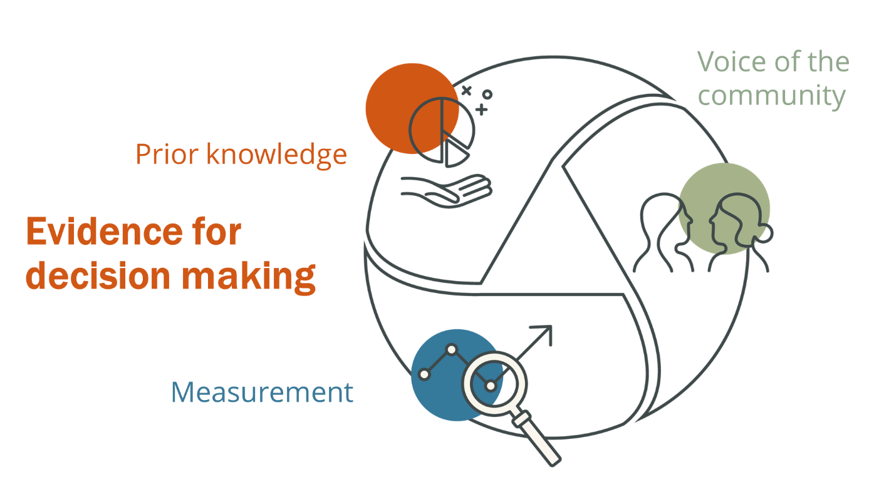
Figure 4: Evidence for decision-making: prior knowledge, measurement and voice of the community

Participants at the key thinkers’ workshop also suggested improving understanding of evaluation methodologies that are based in participation and empowerment, and are therefore well-designed to gather the voice of the community:
- Developmental evaluation – an approach that can help develop social change initiatives in complex or uncertain environments, facilitating real-time (or close) feedback and a continuous development loop (Social Policy Evaluation and Research Unit, 2017).
- Blue Marble evaluation – a global initiative launched in 2015 to promote an evaluation approach based on principles, rather than a specific set of methods or measurements, and which is oriented towards taking future-focused action in a world facing urgent issues such as climate change (Blue Marble, 2023).

Consideration should also be given to using approaches that capture 'authentic collective views', which are not the same as aggregated individual views (King, 2022). This, too, would better facilitate the role of indigenous knowledge within a learning system.

Aotearoa New Zealand provides examples of initiatives that have included a breadth of voices in determining what counts as evidence or knowledge. For example, Ngā Tohu Waiora, a set of over 500 indicators being developed as part of He Ara Waiora, were developed through an extensive wairua-based process led by Māori and supported by government – and as such, they focus on what is important to tangata whenua.

Another case study for communities determining what is important, including what success means to them, is the Monitoring, Evaluation and Learning (MEAL) work stream from the Disability System Transformation work programme (System Transformation). System Transformation built on the success of Enabling Good Lives, recognising the capability of the disability community, and the need to engage them fully in the development of disability policy and services. As such, disabled people were at the heart of the MEAL work stream process. We return to the MEAL work stream when we consider collaborative evaluation.

Action 2: Ensure widespread use of dedicated tools and approaches (such as kaupapa Māori approaches), including more evaluation by Māori, with Māori, for Māori
Using dedicated tools and approaches to understand how the system is working for tangata whenua, particularly those experiencing persistent disadvantage, could help broaden the concept of knowledge informing a learning system – and in doing so, help give effect to Te Tiriti o Waitangi.

Considerations to work through include who can appropriately use these approaches and in which contexts. Government agencies would need to connect more deeply with kaupapa Māori expertise, and work with Māori to agree appropriate ways to promulgate them through the learning system – e.g., whether it would be appropriate to create accountabilities for their use, and if/how the Crown should support kaupapa Māori approaches through guidance or capability building.

Practical steps towards this action could involve emphasising the current guidance from Te Arawhiti on Māori Crown relations, or adopting it more formally, as part of a learning system. Specifically, this could include the Te Arawhiti guidance on:
- organisational capability for agencies, which includes the use of evaluation and data and insights, with the aim that ‘[e]valuation is undertaken by, or in partnership with, Māori’ and uses ‘a wide range of Māori-specific data and insights that are meaningful and useful for Māori and for the organisation’ (Te Arawhiti, Unknown)
- capability for individuals within agencies, which includes understanding mātauranga Māori and kaupapa Māori (Te Arawhiti, Unknown).

Action 3: Engage in collaborative evaluation, including with those experiencing persistent disadvantage
The MEAL work stream discussed previously operates within a tripartite partnership between disabled people and their whānau, Māori and the Crown. Disabled people were integral to its development and play a key role in the ongoing evaluation carried out by the work stream.

The MEAL work stream involves a strong governance and oversight role for disabled people and whānau over what is monitored and evaluated, how these activities are done, and what the information is used for. Outcomes monitored include service quality, effectiveness of the System Transformation, and population-level outcomes for disabled people and whānau. The intention of the wider System Transformation is to introduce co-governance arrangements, to help give effect to Te Tiriti o Waitangi.

The Ministry of Social Development’s Place Based Initiatives (PBIs) are a potential case study for collaborative evaluation. They respond to growing evidence that collective approaches are required to address the needs of Aotearoa New Zealand’s most at-risk children and families. The three PBIs were launched in 2016: the South Auckland Social Wellbeing Board in South Auckland, Manaaki Tairāwhiti based in Gisborne, and Kāinga Ora in Te Tai Tokerau/Northland (which ceased operating in 2019). The learning system element of PBIs involves identifying and influencing practice and system improvements. Manaaki Tairāwhiti does this by identifying barriers at a local level, and feeding them back through their Regional Public Service Commissioner, so government agencies can act on information received.

Action 4: Take a strengths-based approach to evaluation, including moving away from deficit data collection
The interim report observes that “Whānau and rangatahi can be supported to lead the way on intergenerational wellbeing and equity, while support organisations can learn how to apply a strengths-based approach to help them achieve their aspirations” (New Zealand Productivity Commission, 2022, p. 5). Strengths-based approaches can benefit both tangata whenua and other groups experiencing persistent disadvantage. The actions above – taking a broad definition of knowledge, using dedicated tools and approaches like kaupapa Māori, and collaborative evaluation – can all support a strengths-based approach, but a strengths-based approach also rests on what is evaluated.

The kinds of knowledge used for government decision-making purposes can often be deficit-based (in short, this knowledge focuses on who is deemed to be ‘failing’, and how). Whānau Ora offers an example of a strengths-based approach that is based on whānau and their aspirations. The Whānau Ora Commissioning Agency (Whānau Ora 2021/2022, 2022, p. 12) describes the limitations of conventional approaches as follows:

Standard funding models invest in tightly defined services and activities that are specific to a service and programme. They focus on unit costs, prescriptive activity, targets and exacting outputs, making services rigid with little flexibility to respond to changing circumstances and needs. Deficit-focused data requirements ask what is wrong and how to reduce it – creating a missed opportunity to take a more preventative and strengths-based approach. A hierarchical structure sees professionals sitting above service users in decision-making, leaving service users divorced from the design and delivery of their services. Instead, decision-makers are those disconnected from the user experience of the services.

By contrast, Whānau Ora works with whānau to determine what outcomes matter to them, then collaborates with whānau, communities and partners to achieve those outcomes, taking progress against those outcomes as success measures (Whānau Ora Commissioning Agency, 2022).

Action 5: Improve practice around synthesising evidence, including different levels of evaluation
The use of knowledge by a learning system can be thought of as a continuum, starting with knowledge generation. To have impact in the real world, knowledge that is generated must also be effectively collected and synthesised before it can overcome the ‘transmission challenge’ and be translated into use. Synthesis is necessary to bring together different types of knowledge in a holistic manner, to build a bigger picture that takes a temporal view. The role of knowledge synthesis is shown in the diagram below.

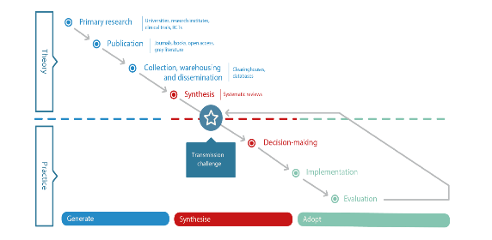
Figure 5: The evidence transmission challenge

The public management system is stronger at generating knowledge than synthesising it. Improved synthesis could start with updating (if required) and re-promulgating the significant body of existing resources created by government. These could include the evidence and evaluation resources developed through the Department of the Prime Minister and Cabinet’s Policy Project (Department of the Prime Minister and Cabinet, 2023); resources from SuperU, including their evaluation guide (Social Policy Evaluation and Research Unit, 2017); and other resources held on The Hub.

Better synthesis would need to be supported in a variety of ways discussed throughout this report, including through all-of-government infrastructure.

Action 6: Take intergenerational and systems-based approaches to evaluation, including a commitment to longitudinal research
We have discussed already the usefulness of a temporal approach to decision-making – hindsight, insight and foresight – and how this might be supported by a learning system. A temporal approach is key to a learning system taking an intergenerational view, and helping the public management system fulfil its stewardship role.

As well as options noted elsewhere (such as better using the IDI), a commitment to stewardship could be expressed by increasing funding to longitudinal studies, such as Growing Up in New Zealand, and by making funding arrangements sufficiently long-term to give these studies greater certainty. This could potentially involve different, stronger or better-resourced partnerships between government agencies and tertiary education providers which, as we discuss, have a high degree of autonomy in relation to their research programmes.

In addition to further funding for longitudinal studies, increased resourcing could be considered for Statistics New Zealand surveys.

Actions to improve knowledge use

Action 7: Share knowledge with and across the system – within government, and between government and other key players
Feedback received through this project indicates that knowledge is not always shared well across government, which may limit knowledge use. Research and evaluation agendas may be formed by agencies without discussion across government, or between government and other key players, and therefore without a system-wide view of what are the important knowledge gaps to address. While some data collections and major outputs are routinely shared (e.g., the New Zealand Health Survey), many others are not, and may be difficult for potential users to find.

In addition to the kinds of knowledge that could be shared through data standards and through information sharing instruments, other forms of knowledge could be shared more systematically (perhaps with the support of all-of-government infrastructure). This more systematic sharing could be included in a government-wide evaluation policy, discussed below, or made a requirement.

Near-term improvements could be made by mapping how agencies are using and sharing knowledge across and beyond government. This, along with international examples, could help create a picture of good practice.

Action 8: Make knowledge accessible to communities, especially people in persistent disadvantage
As above, sharing knowledge between and beyond government agencies is currently limited. Knowledge sharing, while important, is not sufficient; the knowledge must also be accessible.

Making knowledge more accessible could start with looking at agencies’ current practices around sharing information with communities, including where it is done well; what good practice looks like in Aotearoa New Zealand and internationally; and what more could be done. Communities’ views on the usefulness of government information should be sought.

At minimum, work should be stepped up to ensure all government knowledge shared with communities is in appropriate languages, and in formats suitable for disabled people.

Action 9: Facilitate communities to collect and use their own knowledge
As above, MEAL and Ngā Tohu Waiora are examples of communities determining what they see as important, including what success means to them, and translating this into evaluation approaches. Some communities may want to carry out their own evaluations – so there may be a role for government in supporting this, whether through contracting and commissioning, funding, or guidance. There may also be a role for government in developing the workforce (discussed later).

Examples of existing support to communities that could be built on include the evaluation tools developed by SuperU (Social Policy Evaluation and Research Unit, 2017), which are intended for use by any organisation; and the development of the Data Protection and Use Policy (DPUP), which gives principles-based guidance to all organisations (in and outside government) on using people’s information in a respectful, trusted and transparent way (New Zealand Government, 2023). An international example is Evidence2Success, which sets out an approach for involving communities in making investment decisions for evidence-based programmes (The Annie E. Casey Foundation, 2023).

Action 10: Improve practice around making decisions based on evidence and how this flows through to service commissioning
The ‘transmission challenge’ must be overcome to move from knowledge generation to knowledge use. Resources from the Department of Prime Minister and Cabinet’s Policy Project, SuperU and The Hub can all help address this challenge. However, a significant reason for the transmission challenge is the difficulty translating decisions based on knowledge into commissioning, to flow through into improved service delivery. Successfully using knowledge means seeing the value in doing so, and having the capability, tools and mandate.

To help address this problem, the findings of the 2015 More effective social services Productivity Commission report (New Zealand Productivity Commission, 2015) could be built on. As the report sets out (using the report’s terminology), this would help to:
- ensure the social services system creates and shares information about which services and interventions do or do not work well
- consider agreed measures of value (but note that agreed measures will not always be appropriate – e.g., Whānau Ora measures success by the aspirations of each whānau)
- encourage agencies to ensure their social service programmes are subject to rigorous and transparent evaluation
- gather useful information from all ‘levels’ of the social services system
- make sure government takes responsibility for stewardship of MERL across the social services system
- use complaints mechanisms as a form of evidence
- improve the use of ICT in MERL related to the social services system
- ensure good performance information in real time from providers, and use it in better, more transparent and more cost-effective ways
- fund providers to carry out evaluations, and ensure evaluations are commensurate with the size of the organisations involved.

The learning system also needs to build on the Social Sector Commissioning Action Plan (New Zealand Government, 2022), which is intended to transform the way social supports and services are commissioned so they best support people, families and whānau to live the lives they value.

Action 11: Learn what is working in the system, and how to scale where appropriate
The ability to scale initiatives is important in a learning system – not just because scaled services become available to more people, but because the process of scaling itself generates important knowledge. An approach to piloting should be considered that is nimble (so resources and effort can be directed to the best places) but does not always rely on a ‘fast fail’ approach. While fast fail approaches can sometimes be appropriate, other times they will not, because short timeframes may not allow relationships necessary for success to develop.
Note there is a wealth of situational knowledge and expertise on the front line of every social service, which can be disempowered by centrally driven initiatives, including attempts to scale. A top-down approach to scaling innovation can fail to capture and scale the good ideas developed and delivered on the front line, perceiving them as too localised to be scaled up and shared. Scale has four dimensions, spread, depth, breadth, and time:
- Spread is the dimension of scale people are most familiar with – rolling out an initiative across the system.
- Depth is about empowering the frontline professionals who are adopting the innovation, and supporting them to engage with new knowledge and practices. Depth makes implementation meaningful.
- The breadth of scale is the degree to which the community at the site of implementation takes ownership. For an innovation to release all its potential value, the community and professionals delivering it need the autonomy to implement it with all the benefit of their own knowledge, experience, and expertise. Through this process, there is the potential to learn more about how to improve the new initiative, and share that knowledge with other communities.
- Change has to be embedded and sustained across time so that a good idea’s impact is maintained for the long term.

Illustrating the actions that will strengthen knowledge generation and knowledge use
The diagram on the next page shows how the actions described above strengthen learning system components ‘knowledge generation’ and ‘knowledge use’. This diagram builds on the Key Players diagram and shows how these actions will require (and help create) strong relationships between the Crown, funders, providers, tangata whenua, and those experiencing persistent disadvantage.
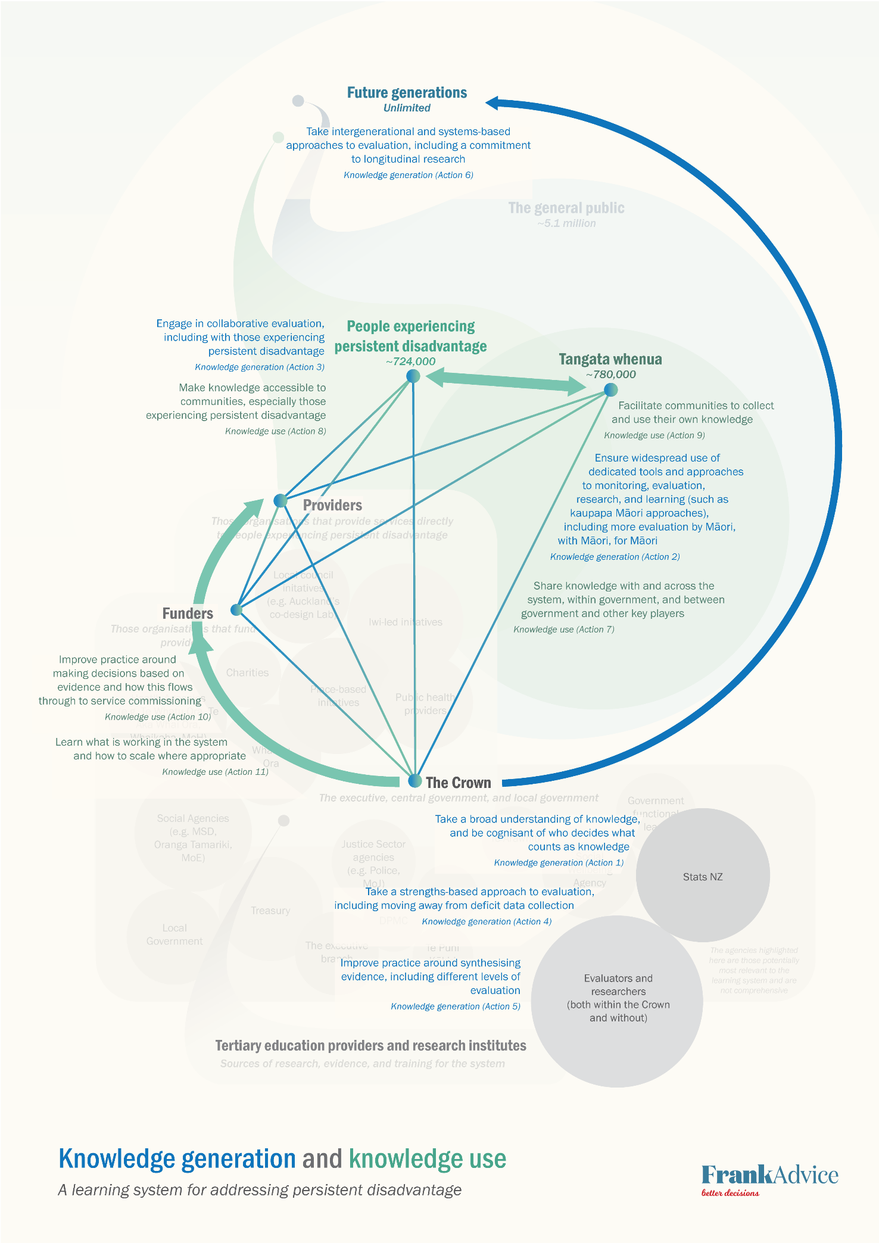
Figure 6: Knowledge generation and knowledge use diagram
Actions to improve leadership

Action 12: Establish an all-of-government leadership function, to ensure the Crown plays its part in a learning system
As noted, perhaps the greatest challenge in creating a learning system is not in knowing what to do, but ensuring people and organisations do it. Leadership is critical to making sure everyone plays their part in a learning system. In keeping with recommendation 6.9 of the interim report – that an all-of-government system functional lead role should be designated for system learning and improvement – we consider what a leadership function could look like for a learning system in Aotearoa New Zealand.

The beginning of this report outlined the limitations in looking to international models when considering the design of a learning system for Aotearoa New Zealand. However, we think that drawing on the Canadian monitoring and evaluation system can help illustrate the key potential elements of a learning system. Lahey & Nielsen (2013), in describing the features of the Canadian system, point to the central leadership function, and the different types of activities that the leadership function is charged with (these activities also appear in the actions of this report, although sometimes in different terminology, and with some additions).

We note that form should follow function, so the specific design of a leadership function would depend on the specific tasks it is charged with. For example, there are questions about what responsibilities a leadership system might hold vis a vis the agencies within the system, and who might hold responsibility for strategy, planning and investment, and for actually carrying out system activities (Washington, 2022 a). We do not consider these questions here, but note they would need further exploration.

For the purposes of the current discussion, we assume that a leadership function would need to be designed so as to carry out any or all of the actions in this report. Critically, this means including tangata whenua at its foundations, and through every aspect, including all levels of leadership (discussed later). It might also include a role in workforce development (not part of the Canadian model).

Part of this project involved considering from a machinery of government perspective where a leadership function for a learning system might sit. We see that there are two broad options for a leadership function:
- housing the leadership function within an existing agency, or
- creating a new standalone entity for the purpose.

Of these two broad options, we think that a new standalone agency created for the purpose is likely to have the greatest impact. It would be designed specifically to carry out its tasks (including leadership arrangements to give effect to Te Tiriti o Waitangi) and to embody the values of He Ara Waiora, would bring together a high level of expertise into a single place, and would have a high degree of independence.

However, there would also be disadvantages and risks to a new standalone entity, to be weighed against the advantages. There would likely be a greater cost and a time lag in setting it up (if it was a new agency, it would likely require legislation to establish); it may not be able to access the operational capacity of a host organisation; it would have to build its own relationships and capability from the ground up; and it might draw evaluation expertise away from other organisations, creating gaps.

To guide a recommendation on where the leadership function of a learning system might sit, we have identified the attributes a leadership function would need, in order to carry out the actions we have identified and fulfil the components of a learning system. In the table that follows, we set out these attributes, explain what they are and why they matter, and provide commentary on the extent to which existing entities embody those attributes.

In Table 3 below, we set out what we see as the key attributes of a learning system leadership function. We started with a list of agencies we considered might be able to fulfil a leadership function, because they have existing roles in system leadership and/or knowledge and evaluation:
- Department of the Prime Minister and Cabinet
- Ministry of Social Development
- Office of the Auditor General
- Social Wellbeing Agency
- Statistics New Zealand
- Te Kawa Mataaho Public Service Commission
- Treasury.

In the commentary in the table, we then consider which of the agencies above have strengths in relation to the leadership function attributes.
Note that submitters to the inquiry gave feedback that:
- The central leadership function for a learning system ought to be held by the Department of Prime Minister and Cabinet or Te Kawa Mataaho Public Service Commission.
- The central leadership function ought to be required to draw on the advice of a joint central/local board.
- The Public Service Act 2020 should be amended so heads of government agencies have statutory independence in developing MERL strategies.

Table 3: Attributes of a leadership function
Attribute of a learning system leadership function | Commentary
Expertise in knowledge and evaluation | Having existing expertise in evaluation, from both working level through to senior leadership, would be integral to leading a learning system.  Agencies with the strongest existing expertise in evaluation (and measurement) at all levels are the Social Wellbeing Agency, Statistics New Zealand, and Treasury.
Trusted relationships with community stakeholders and partners | Relationships with community stakeholders and partners would be necessary to ensure that a breadth of knowledge, including community voices, form part of a learning system.  While many or most of the agencies we considered have external relationships, the agency with the strongest trusted relationships in this context is the Ministry of Social Development (because it has an extensive range of contractual relationships with providers).
Knowledge of kaupapa Māori and te ao Māori | While Te Puni Kōriri and Te Arawhiti hold knowledge of kaupapa Māori and te ao Māori, or work closely with those who do, we did not consider them within scope of this exercise. We note there may be some limited capability within the Ministry of Social Development and Social Wellbeing Agency.
Level of independence from agencies to be monitored | To hold the public management system to account, the leadership function for a learning system would need to able to maintain independence from agencies making up the system. However, it would need to be sufficiently connected with the substance of the learning system, and have enough understanding of persistent disadvantage, that it could lead effectively.  Agencies with a suitable level of independence might be Te Kawa Mataaho Public Service Commission, Statistics New Zealand, Treasury, or the Office of the Auditor General.
Ability to give effect to the values of a learning system | The learning system will need to uphold the values of He Ara Waiora and a commitment to Te Tiriti o Waitangi. This entails the ability to challenge the status quo, including understandings of what constitutes knowledge and conventional evaluation practices.  The mandates and roles of existing agencies would make it difficult for them to offer this challenge.

Action 13: Establish leadership arrangements with Māori at all levels of the learning system
Making space for tangata whenua to lead and hold power in a learning system could take a number of forms, from governance arrangements through to organisational and individual capability within agencies, as discussed above. Shared leadership between Māori and the Crown can be expressed in a range of ways, and may raise complex issues which are outside the scope of this report. However, whichever forms are considered, it will be critical to give weight to the findings of Haemata Limited (2022) on the nature of trust between the public management system and Māori:
- trust is relational
- tikanga builds trust and confidence
- the power imbalance (between the public management system and Māori) thwarts trust.

Actions to improve accountability

Action 14: Prioritise equity for tangata whenua when making decisions to address persistent disadvantage
A learning system should prioritise equity, and in particular, equity for tangata whenua. Equity considerations need to be built into knowledge generation and knowledge use. Existing models, such as PHARMAC’s Factors for Consideration framework, may offer examples that could be drawn on. Funding decisions taken under the Factors for Consideration explicitly consider the impacts on health outcomes for people experiencing health disparities, including Māori (PHARMAC, 2023).

Current obligations to provide equity analysis (such as the required ‘population implications’ section of Cabinet papers) are weak, and do not necessarily have real world impacts. Consideration should also be given to introducing accountabilities for decision-makers to act on the results of equity analysis (discussed later).

Action 15: Ensure government agencies work with people to understand and evaluate what matters to them, as determined by them
Accepting that a learning system works with knowledge (not the narrower concept of evidence) means there must be willingness to gather that knowledge, including the wisdom of communities.
Standards for engagement for the purposes of knowledge-gathering could be promulgated. The Department of the Prime Minister and Cabinet has recently included engagement guidance amongst its Policy Project resources, including guidance developed by Te Arawhiti for engaging with Māori. The Department of Internal Affairs and Te Kawa Mataaho Public Service Commission in their Long-term Insights Briefings call for better guidance or a whole-of-government ‘framework’ for engagement. A stronger and more joined-up approach to engagement by government departments is needed to give effect to the participatory decision-making referred to in the interim report (Washington, 2022 a).

Action 16: Establish a government-wide knowledge policy that includes evaluation
A knowledge policy should be developed that applies to all of central government, and potentially local government. At a minimum, it should specify responsibilities for undertaking evaluation, when evaluation should be carried out, and should make clear the responsibilities of government to empower and support other partners and stakeholders, including in the community, to carry out their own evaluation (if they wish to do so).

For example, a knowledge policy might concern itself not just with who should do what, but also the standards of evidence that should be used as part of public management system decision-making. An example of this approach is the guide Show your workings: assessing how government uses evidence to make policy, by the Institute for Government in the UK (Rutter & Gold, 2015).

Action 17: Establish requirements and standards of practice for government agencies
Consideration should be given to going further than a government-wide knowledge policy (or using other ‘soft’ levers like guidance), and establishing requirements and standards of practice agencies must meet in their knowledge activities. A number of the potential actions in this report could form the basis of standards and requirements.

Action 18: Equip the all-of-government leadership function with powers to make agencies accountable
One of the key decisions in a learning system includes what responsibilities agencies in a learning system have relative to the leadership function, and the levers the central leadership function might be given to ensure agencies play their part. It would be expected that agencies have learning system responsibilities flowed into their normal accountabilities – for example, their accountability documents (such as annual reports), right through to Budget documents.

In addition, the leadership function might have its own powers to report – these could potentially be established in legislation. An example of an entity with reporting powers established in legislation is the Mental Health and Wellbeing Commission. The 2020 Act establishing the Commission not only gives it the power to publicly report on any matters concerning the mental health and wellbeing of people in New Zealand, it can also
make recommendations to any person (including any Minister) on any matters concerning mental health and wellbeing, and has certain powers to obtain information. The Act requires that the Commission’s Board has knowledge of te ao Māori, tikanga Māori and whānau-centred approaches to wellbeing.

If a leadership function was given powers to make agencies accountable, careful thought would have to be given to possible tensions with other of its powers. For example, if the leadership function had the ability to hold agencies accountable for performance, agencies may be less inclined to have the candid discussions involved in seeking guidance to improve their performance. (A centre of excellence may address this tension – this is discussed further below.)

Action 19: Consider recommending to Ministers that government agencies be required to provide advice based on knowledge generated by the learning system
One reason for the knowledge transmission challenge is that, even when knowledge is produced, there may be a lack of will or accountability for using that knowledge. Consideration needs to be given to recommending to Ministers that government agencies be required to provide advice based on the evidence generated by the learning system, including the risks and benefits of current and proposed policies. This would increase transparency around the effectiveness of the public management system in addressing persistent disadvantage, because it would make clear what is and is not working – and it would increase visibility over whether Ministers are taking evidence-based decisions. Being able to demonstrate the evidence base for their decisions may help Ministers and other decision-makers be less risk averse.

Consideration might also be given to advising Ministers to adopt a policy whereby agencies are required to publish the results of evaluations, and potentially other forms of knowledge. Such an approach would need to be managed carefully to avoid perverse incentives (e.g., to not conduct evaluations in the first place).

Illustrating the actions that will strengthen leadership and accountability
The diagram on the next page shows how the actions described above strengthen the learning system components of ‘leadership’ and ‘accountability’. The diagram shows the central role of the all-of-government leadership function, and how each of the key players could be involved in leadership and accountability.

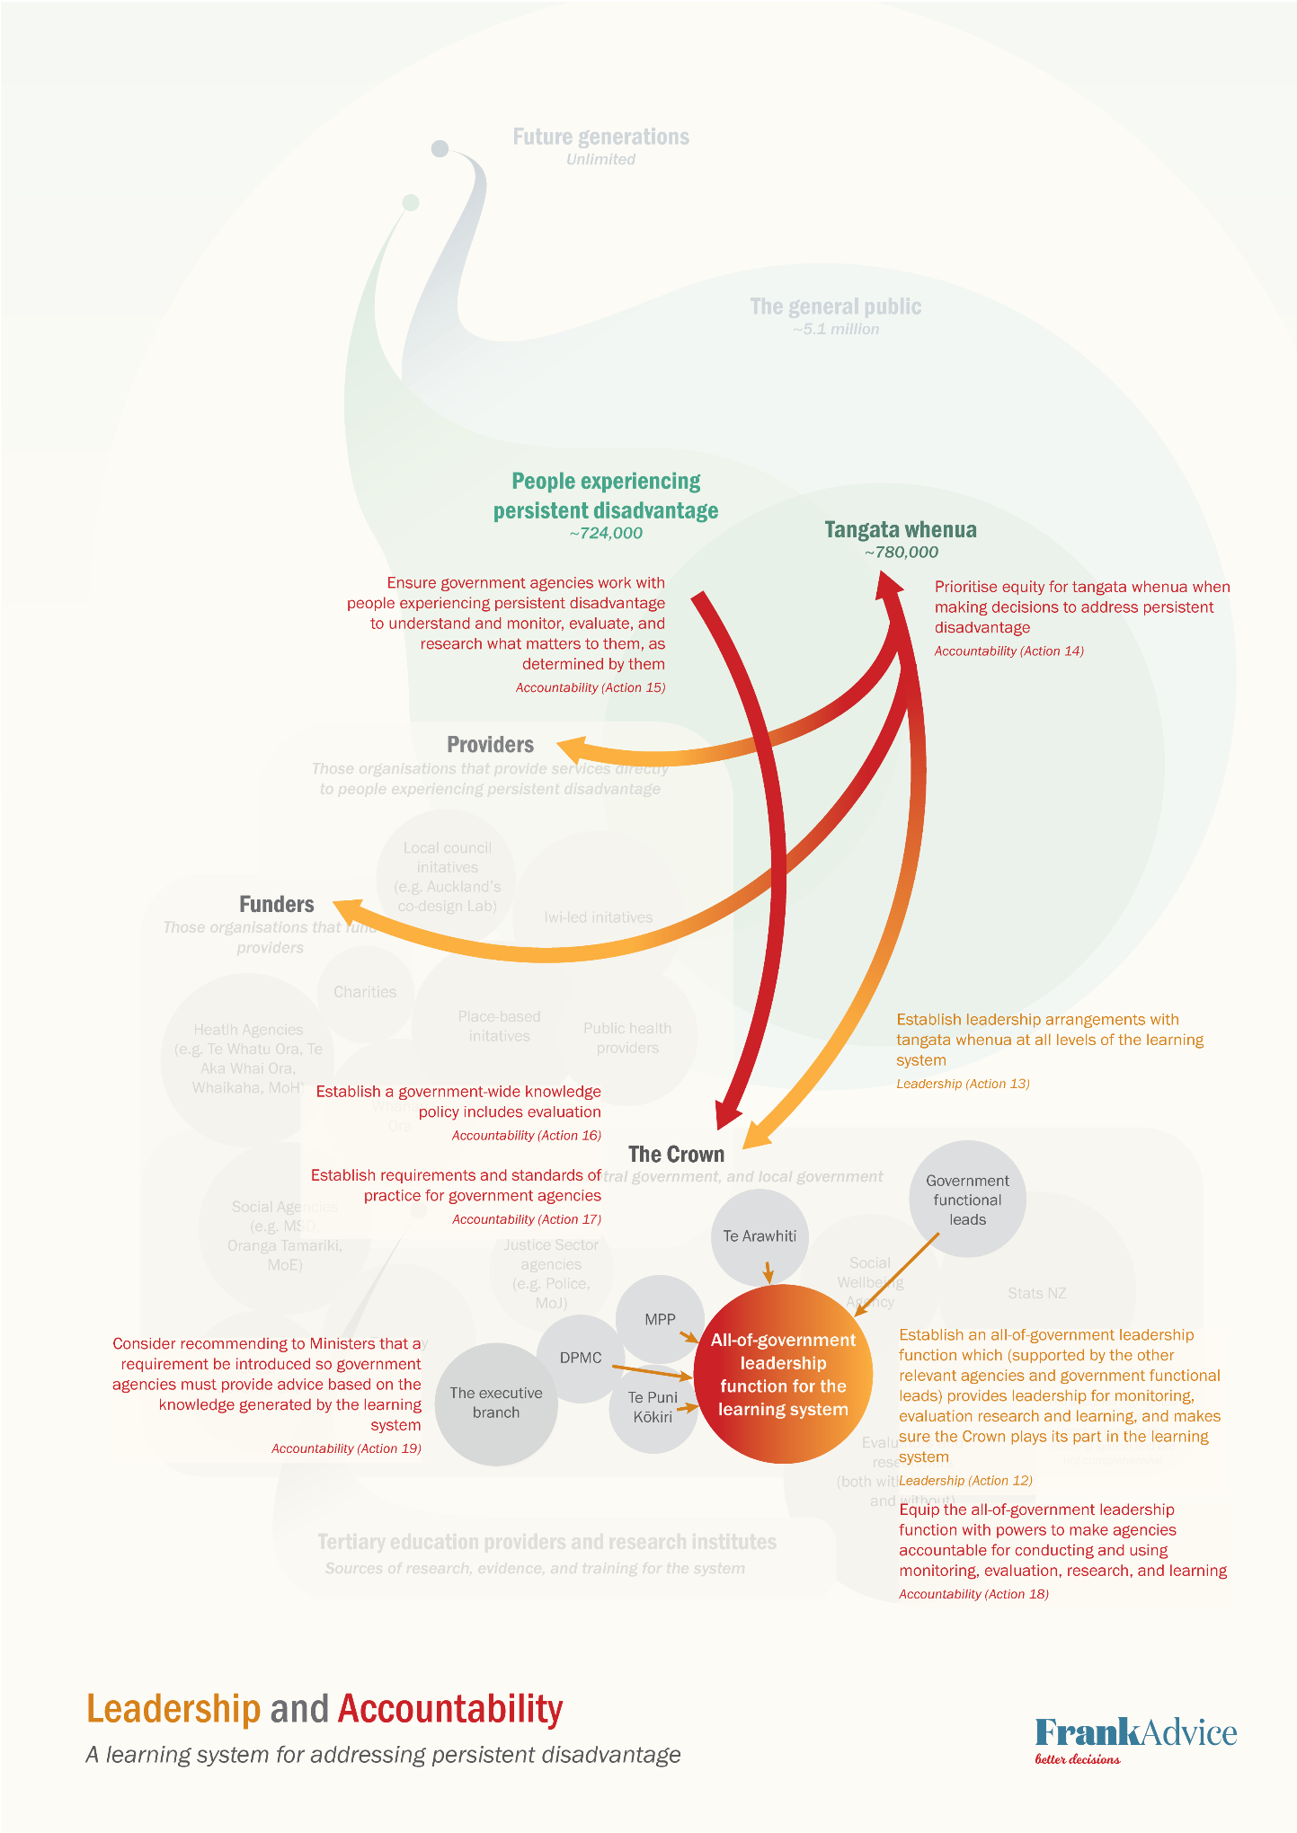
Figure 7: Leadership and accountability diagram
Actions to improve capability

Action 20: Strengthen cross-government infrastructure for evaluation
In the following discussion of cross-government infrastructure for evaluation, we focus primarily on strengthening data standards and making greater use of the IDI. We note that this discussion is not exhaustive.

Standards, including data standards, are a key part of the cross-government infrastructure for evaluation. Currently, data standards are sometimes used to establish a common approach to the collection, management, and use of data. The Government Chief Data Steward has the power to make data standards mandatory, and mandated standards must then be used by government agencies when collecting, publishing or sharing data on a topic. Strengthening standards could maximise the value of data already collected across government, facilitate collaboration between agencies by making it easier to share data, and enable a wider view of what is happening.

There are currently only four mandated data standards – name, date of birth, address, and gender and sex – but work is underway to mandate ethnicity, iwi affiliation, Māori descent, and Māori business.

There are other standards that could be created and adopted to support a learning system:
- data ethics
- data governance (including models for Māori co-governance of data)
- data management (e.g., how to set up and use data dictionaries, accuracy, custodianship, etc)
- data storage (but note that work is needed in this area, especially in relation to Māori data sovereignty)
- data stewardship
- data capability (a framework currently exists).

Guidance in most of these areas currently exists but is not well used or understood across the public management system.

In addition, the IDI has potential to be used to greater effect as part of a learning system. It is useful to think of this potential from a temporal point of view:

Recent work by NZIER underscores that, although more than 700 projects have used IDI data, there is potential for greater use, but this requires ongoing social licence (NZIER, 2022, p. 6): ‘Despite the various benefits of the IDI, the existence of the database is still, in many ways, unknown to the general public. Like many organisations, public trust is vital to Stats NZ’s operation. Given the vast amount of individual-level data in the IDI, this database’s existence needs to retain public trust, and this requires purposeful management’. This social license issue links to other issues canvassed in this report, including Haemata Limited’s (2022) discussion of the nature of trust between the public management system and Māori.

Because of the nature of existing cross-government infrastructure and evaluation practices, the primary focus for government data collections is quantitative data. Therefore, our comments in relation to data standards and the IDI concern what improvements could be made within the parameters of the government’s existing approach to evaluation.

However, further consideration is required to understand what kind of infrastructure would be needed to appropriately protect, share, and make use of other forms of knowledge than only data, including indigenous knowledge – and how this infrastructure might be resourced, developed and governed. New infrastructure would have to be able to capture authentic collective views (King, 2022). Many of the actions proposed in this report would be difficult to realise without such new infrastructure.

Action 21: Establish a (separate) centre of excellence for the learning system
The learning system may require a source of expertise that agencies can draw on to improve their practice. As above, giving the leadership function the tasks of both ensuring agencies are accountable and supporting them to lift their performance may create a tension. One option to avoid this tension is to establish a centre of excellence for a learning system. An agency may be more inclined to have candid discussions about capability with, and seek support from, an organisation that does not have any role in monitoring its performance. The support offered to agencies by a centre of excellence might include helping them to build understanding of different evaluation approaches, and to develop the capabilities to carry them out.

Key questions for the design of a centre of excellence would include whether the centre of excellence:
- is part of an existing entity, or a new standalone entity. Although a standalone entity would not have the advantage of being able to access the operational capacity of an existing agency, it would have greater independence.
- should provide support to agencies in kaupapa Māori approaches; or whether this expertise more appropriately sits outside of government.

Other forms of independent, centralised expertise could be considered that stop short of establishing a centre of excellence. For example, a clearinghouse could be established to host both knowledge necessary to run the system (e.g., evidence on what works), as well as knowledge generated by the learning system. The UK’s What Works Network provides an example of how centralised repositories of knowledge can work (The Government of the United Kingdom, 2023).

Action 22: Develop the evaluation workforce
If government established a learning system, this would likely increase the demand for evaluators, including those skilled in kaupapa Māori approaches. A leadership function for a learning system might include a workforce function, responsible for:
- working with external parties (e.g., tertiary education providers) to promote evaluation as a career
- ensuring a workforce pipeline
- supporting the capability of the existing workforce.

It may be possible to draw insights from the Workforce Development Council model, or from agencies that have responsibilities for particular workforces, on how a workforce function for a learning system could operate.

Action 23: Understand and address incentives in the public management system, so people play their part in a learning system
Incentives on policymakers (including incentives for short-termism and status quo bias) are influenced by ‘demand side’ decision makers, including Ministers. While constitutional matters are outside the scope of the inquiry, the public management system can influence Ministers through advice.

Effective engagement with decision makers requires support that has codifiable aspects: leadership, policy quality systems, people capability, and engagement (Washington, 2022 a). When this engagement is effective, it can be better used to advise Ministers on the value of evidence.

Advice to Ministers could include a range of ways for Ministers to address incentives for short-termism and status quo bias – including some discussed elsewhere in this report, such as publishing the results of evaluations, or a requirement to develop advice based on knowledge generated by the learning system. Ministers might also consider a requirement that intergenerational wellbeing is incorporated in advice and/or Cabinet papers.

However, Ministers are not the only actors in the public management system affected by incentives. At all levels, perceived failure can have implications for career progression, which creates risk aversion. Moving beyond this risk aversion will involve developing a greater willingness to innovate, which will in turn mean accepting a certain level of risk. Rigorous evaluation of initiatives will both help manage the level of risk, and ensure that whatever the outcome, the public management system can learn lessons from it.

Action 24: Identify and use levers to improve government evaluation capability
In addition to other potential actions, such as a centre of excellence, it may be useful to develop a cross-government framework setting out the capabilities required for evaluation. This framework could draw on the Ministry for Pacific Peoples’ Kapasa and Yavu frameworks, or the Department of the Prime Minister and Cabinet’s Policy Project. However, any framework would not be able to rely on ‘passive’ distribution, and would need to consider how to encourage active engagement and uptake.

Levers to support – and ensure uptake of – a cross-government evaluation capability framework are likely to include recruitment and professional development policies, resourcing decisions within agencies, and expectations on chief executives to improve capability. A framework could also extend to career pathways for researchers and evaluators into government, and to cross-government initiatives to build capability (a potential aspect of a central leadership function).

Actions to improve capacity

Action 25: Place a requirement on agencies to dedicate resourcing to evaluation
Currently, there is no easy way to determine what proportion of government agencies’ spending goes towards evaluation. Feedback from the key thinkers workshop indicated that, while Treasury at one point required all Budget initiatives to include a provision for evaluation, there was no follow-up to ensure the evaluation happened. A commitment to funding evaluation would not only potentially require more resourcing, but a process to ensure that resourcing was spent as intended.

Treasury, with the support of the leadership function for the learning system, could design and enforce a requirement that agencies must dedicate a certain percentage of spending to evaluation (either a percentage of spend on initiatives able to be evaluated, or of overall spending). The Office of the Auditor-General might have a role in ensuring this requirement is met.

Illustrating the actions that will strengthen capability and capacity
The diagram on the next page shows how the actions described above strengthen the learning system components ‘capability’ and ‘capacity’. The diagram shows the required relationships between government agencies, the relationship between the cross-government leadership function and the centre of excellence, and the role of tertiary education and providers in strengthening capability and capacity.

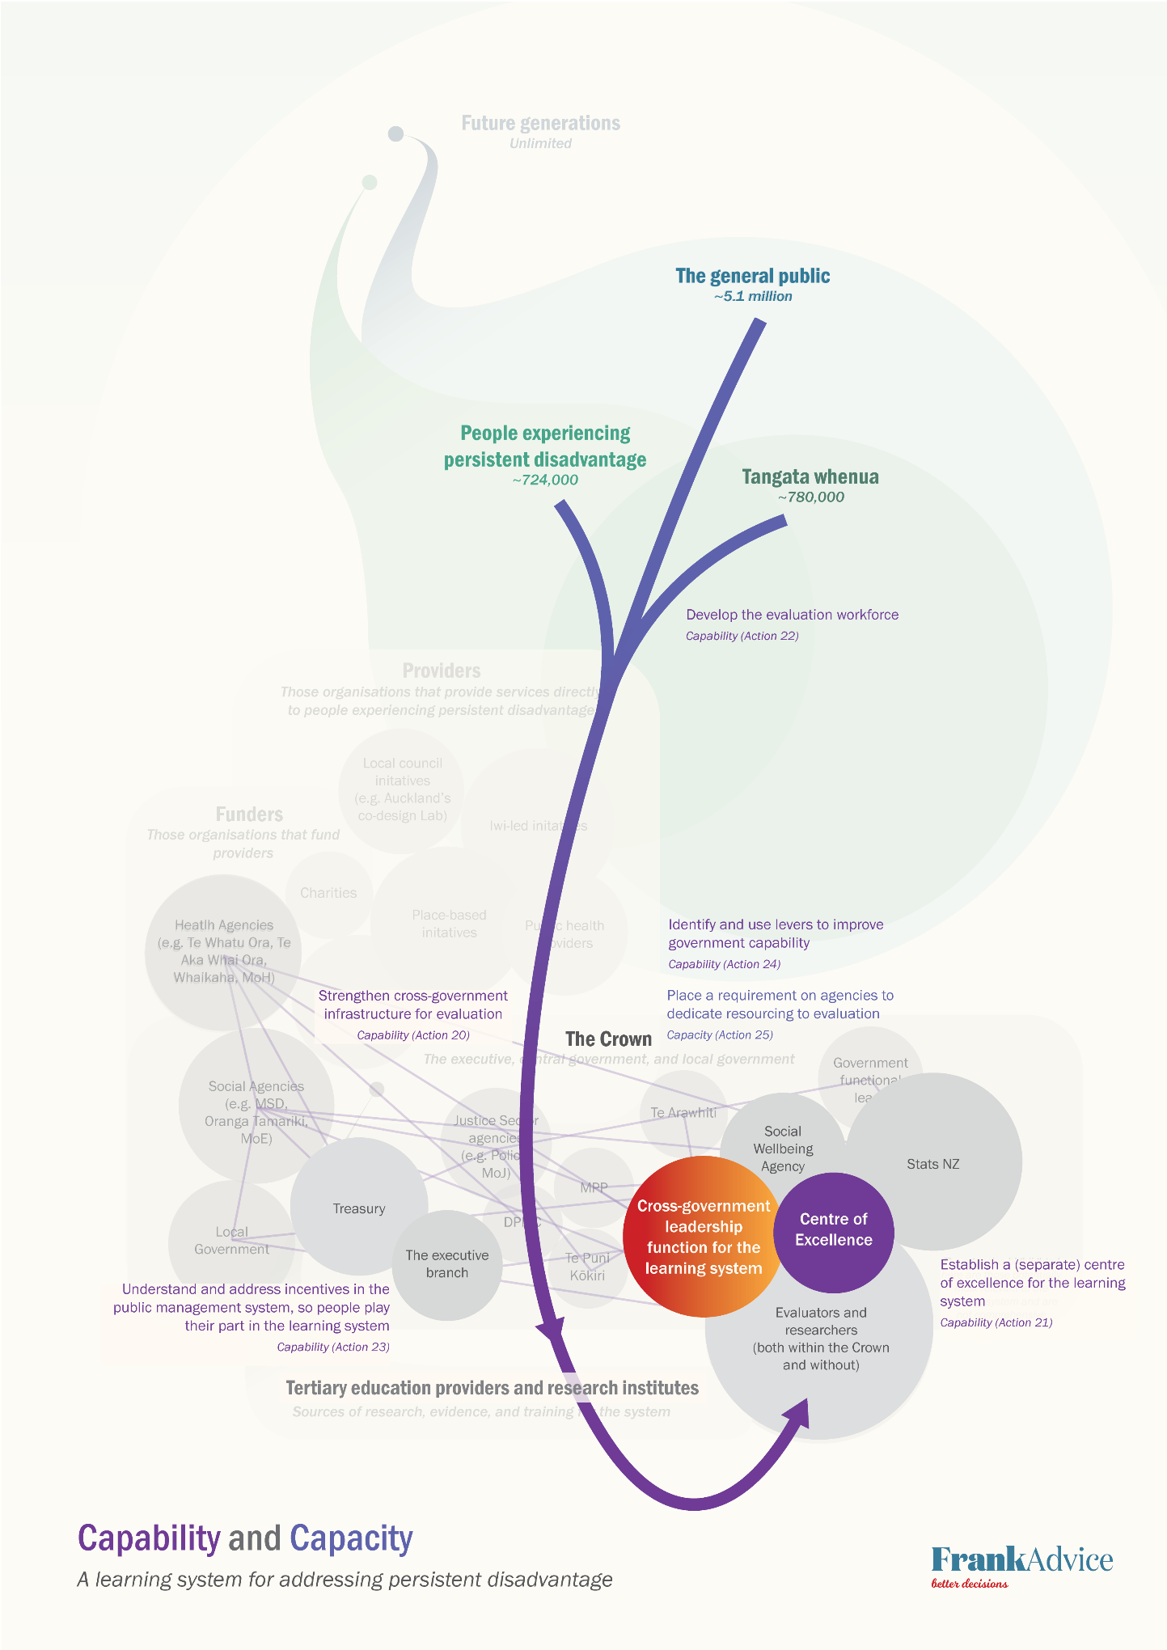
Figure 8: Capability and capacity diagram

Summary of potential actions
There are six key components in an effective learning system: knowledge generation, knowledge use, leadership, accountability, capability, and capacity. Actions within each component are summarised below.

Actions to improve knowledge generation

Action 1: Take a broad understanding of knowledge, and be cognisant of who decides what counts as knowledge
A learning system should recognise a breadth of knowledge: not just monitoring, evaluation, research and learning, but deep engagement with the voices of those who will be affected by a given decision. Valuing 'authentic collective views' from communities will help lead to more inclusion of indigenous knowledge.

Action 2: Ensure widespread use of dedicated tools and approaches (such as kaupapa Māori approaches), including more evaluation by Māori, with Māori, for Māori
A learning system that has widespread use of kaupapa Māori approaches and more evaluation by Māori, with Māori, for Māori will enable a greater understanding of how the system is working for tangata whenua, particularly those experiencing persistent disadvantage.

Action 3: Engage in collaborative evaluation, including with those experiencing persistent disadvantage
Communities who use the services or programmes being evaluated need to play a key role in the evaluation of those services or programmes.

Action 4: Take a strengths-based approach to evaluation, including moving away from deficit data collection
Actions 1 to 3 all support a strengths-based approach, but what is evaluated is also important. Evaluations need to focus outcomes that matter to people, and on progress towards those outcomes.

Action 5: Improve practice around synthesising evidence, including different levels of evaluation
Improving the synthesis of evidence will ensure different types of knowledge are brought together holistically and translated into a useful bigger picture.

Action 6: Take intergenerational and systems-based approaches to evaluation, including a commitment to longitudinal research
A temporal approach – hindsight, insight, foresight – is key to a learning system taking an intergenerational view, and helping the public management system fulfil its stewardship role. Better use of the IDI and increased funding for longitudinal studies could contribute.

Actions to improve knowledge use

Action 7: Share knowledge with and across the system – within government, and between government and other key players
Knowledge is not always shared well within and beyond government, and agency research and evaluation agendas maybe formed without wider discussion. More systematic sharing could be included in a government-wide evaluation policy.

Action 8: Make knowledge accessible to communities, especially people in persistent disadvantage
Knowledge should be shared with communities in accessible ways. This could include determining what good practice knowledge sharing looks like, seeking communities’ views on what is useful information, and ensuring information is shared in a range of languages s well as formats suitable for disabled people.

Action 9: Facilitate communities to collect and use their own knowledge
Communities need to be supported to carry out their own evaluations, whether that is through building on existing evaluation tools developed for organisations both within and outside government, or by commissioning, funding, and guiding community evaluations.

Action 10: Improve practice around making decisions based on evidence and how this flows through to service commissioning
A learning system should be dedicated to making it easier to translate decisions into commissioning and then into improved service delivery, using the findings of the Productivity Commission’s 2015 report on More effective social services.

Action 11: Learn what is working in the system, and how to scale where appropriate
The ability to scale initiatives is important in a learning system, partly because the process of scaling generates important knowledge. Approaches to scaling and piloting need to reflect the wealth of situational knowledge and expertise on the front line, as well as the four dimensions of scale: spread, depth, breadth, and time.

Actions to improve leadership

Action 12: Establish an all-of-government leadership function, to make sure the Crown plays its part in a learning system
An all-of-government leadership function should give effect to Te Tiriti o Waitangi, but could also draw on the Canadian monitoring and evaluation system’s central leadership function. Form needs to follow function, so a leadership function should be designed to carry out any or all the actions in this report. Creating a new standalone entity is likely to have a greater impact than housing a leadership function within an existing agency, but would also come with a greater cost and longer timeframe for establishment.

Action 13: Establish leadership arrangements with Māori at all levels of the learning system
Shared leadership between Māori and the Crown can be expressed in a range of ways, but the nature of trust between the public management system and Māori is a critical aspect. Leadership arrangements with Māori should be established throughout a learning system, from governance arrangements through to organisational and individual capability within agencies.

Actions to improve accountability

Action 14: Prioritise equity for tangata whenua when making decisions to address persistent disadvantage
Equity considerations should be built into knowledge generation and knowledge use. Current obligations to provide equity analysis (such as the required ‘population implications’ section of Cabinet papers) are weak, and do not necessarily have real world impacts.

Action 15: Ensure government agencies work with people to understand and evaluate what matters to them, as determined by them
Ensuring evaluations reflect what matters to communities who use the services is needed to give effect to the participatory decision-making referred to in the interim report. This action could include promulgating standards for engagement for the purposes of knowledge-gathering – such as the guidance developed by Te Arawhiti for engaging with Māori.

Action 16: Establish a government-wide knowledge policy that includes evaluation
A learning system could include a government-wide knowledge policy that specifies responsibilities for undertaking evaluation, when evaluation should be carried out, and the responsibilities of government to empower and support other partners and stakeholders to carry out their own evaluations (if they wish to do so).

Action 17: Establish requirements and standards of practice for government agencies
A learning system could go beyond providing guidance by establishing requirements and standards of practice for government agencies. Many of the potential actions in this report could form the basis of standards and requirements.

Action 18: Equip the all-of-government leadership function with powers to make agencies accountable
Holding agencies accountable could include giving the leadership function powers to obtain information from agencies, report on their learning and evaluation performance, and make recommendations. Agencies themselves could have learning system responsibilities included in their normal accountability documents, such as annual reports and Budget documents.

Action 19: Consider recommending to Ministers that a requirement be introduced so government agencies must provide advice based on knowledge generated by the learning system
Agencies could be required to provide advice based on the learning system’s knowledge, including the risks and benefits of current and proposed policies. This requirement would help to address the transmission challenge by ensuring generated knowledge is put to use. It would also increase transparency by making it clear what is and is not working in addressing persistent disadvantage, and whether the government is making evidence-based decisions.

Actions to improve capability

Action 20: Strengthen cross-government infrastructure for evaluation
A learning system could strengthen cross-government infrastructure for evaluation by creating and mandating more data standards and making greater use of the IDI. Strengthened infrastructure should also support protection, sharing and use of forms of knowledge other than data, including indigenous knowledge.

Action 21: Establish a (separate) centre of excellence for the learning system
A centre of excellence could help agencies build understanding of different evaluation approaches and develop the capabilities to carry them out. Having a separate centre would avoid the tension of a leadership function that is tasked with both holding agencies accountable and supporting them to lift their performance.

Action 22: Develop the evaluation workforce
A central leadership function could include a workforce function to ensure a workforce pipeline (given a learning system would likely increase the demand for evaluators), promote evaluation as a career, and grow the capability of the existing workforce.

Action 23: Understand and address incentives in the public management system, so people play their part in a learning system
Incentives on policymakers and decision makers often lead to short-termism, status quo bias, and risk aversion. To increase the value placed on evidence, a learning system should encourage or require publishing the results of evaluations, developing advice based on knowledge generated by the learning system, and developing a greater willingness to innovate that includes accepting a certain level of risk and focussing on lessons learned.

Action 24: Identify and use levers to improve government evaluation capability
A cross-government framework setting out the capabilities required for evaluation, drawing on existing tools and frameworks, may be useful, and could be used to create career pathways for researchers and evaluators into government. Agencies would need to use appropriate levers to ensure uptake of the framework.

Actions to improve capacity

Action 25: Place a requirement on agencies to dedicate resourcing to evaluation
Creating a requirement on agencies to resource evaluations would address concerns that agencies may fail to undertake promised evaluations and provide transparency about the proportion of agencies’ spending on evaluation. Such a requirement could include creating a process to ensure that evaluation resourcing was spent as intended, with oversight from the Office of the Auditor-General.

Appendix 1: Key thinkers workshop – attendees and questions discussed
Table 4: Full list of workshop attendees
Name | Role and affiliation
Juliet Gerrard | Prime Minister’s Chief Science Advisor
Andrew Webber | Chief Economist, Social Wellbeing Agency
Alex Brunt | Deputy Chief Executive, Social Wellbeing Agency
Sankar Ramasamy | Chief Evaluator, Education Review Office
Penny Hagen | The Southern Initiative / Auckland Council
Graham Scott | Former Secretary of the Treasury
Claudia Scott | Emeritus Professor, School of Government, Victoria University of Wellington
Hugh Webb | Child Wellbeing and Poverty Reduction Group, Department of the Prime Minister and Cabinet
Emma Powell | Te Puna Aonui
Steve Murray | Evidence Centre, Oranga Tamariki
James McIlraith | Evidence Centre, Oranga Tamariki
David Stuart | Ministry of Culture and Heritage
Josh Palmer | Te Puni Kōkiri
Claire Bretherton | Te Puni Kōkiri
Nan (Ngahorihori) Wehipeihana | Kinnect
Catherine Proffitt | Productivity Commission
Jason Timmins | Productivity Commission
Carolyn O'Fallon | Productivity Commission
Nigel Taptiklis | Productivity Commission
Michelle Pawson | Productivity Commission
Anna McMartin | FrankAdvice
Emily Mason | FrankAdvice
Kellie Spee | Facilitator
Judy Oakden | Facilitator

Workshop questions

- Identify key groups of stakeholders and partners
- What is at stake for each of the stakeholder and partner groups?
- What do we need from a learning system? What are the enablers of a learning system?​
- What currently exists? What are we doing now? What could we do more of?​
- Where are the gaps? What can we do about them?

Reflective questions (provided to attendees at the end of the workshop)

- Who are the stakeholders and partners in a learning system to enable the public management system to address persistent disadvantage?
- Who do you think should be prioritised?
- What do we need from a learning system? What are the enablers of a learning system?
- What’s the biggest shift (in values/actions/perceptions etc.) you’d like to see first?
- What do you think the most essential support would be for the learning system?
- What currently exists? What are we doing now? What could we do more of?
- Do you know of any specific examples of best practice in learning, monitoring, and evaluation in the public management system that should be used more widely?
- Where are the gaps? What can we do about them?
- If your favoured approaches were not possible, what do you think would be the best alternatives?
- What are things we should do in the next 3 years? The next 10 years? The next 30?

Interviewees (unable to attend workshop)

Table 5: Interviewees
Name | Role and affiliation
Len Cook | Former Chief Executive of Statistics New Zealand
Julian King | Julian King and Associates Consulting Services

Appendix 2: Bibliography
Blue Marble Evaluation. (n.d.). Accessed at https://bluemarbleeval.org/

Department of the Prime Minister and Cabinet. (2023). The Policy Project. Accessed at https://dpmc.govt.nz/our-programmes/policy-project

Gayithri, K. (2019). Monitoring and evaluation of government programs in India and Canada. Nation-Building, Education and Culture in India and Canada: Advances in Indo- Canadian Humanities and Social Sciences Research, 171-185.

Goldman, I., Byamugisha, A., Gounou, A., Smith, L. R., Ntakumba, S., Lubanga, T., ... & Rot- Munstermann, K. (2018). The emergence of government evaluation systems in Africa: The case of Benin, Uganda and South Africa. African Evaluation Journal, 6(1), 1-11.

Haemata Limited. (2022). Māori Perspectives on Public Accountability. Accessed at https://oag.parliament.nz/2022/maori-perspectives/docs/maori-perspectives.pdf

Lahey, R., & Nielsen, S. B. (2013). Rethinking the relationship among monitoring, evaluation, and results‐based management: observations from Canada. New Directions for Evaluation, 2013(137), 45-56.

Ministry for Pacific Peoples. (2022). All-of-Government Pacific Wellbeing Strategy. Accessed at https://www.mpp.govt.nz/programmes/all-of-government-pacific-wellbeing- strategy/

Mulgan, G., Marsh, O., & Henggeler, A. (2022). Navigating the Crisis: How Governments Used Intelligence for Decision Making During the COVID-19 Pandemic. Accessed at https://dx.doi.org/10.2139/ssrn.4304021

NZIER. (2022). How big data can be a force for good – NZIER Insight 103. Accessed at https://www.nzier.org.nz/publications/how-big-data-can-be-a-force-for-good-nzier- insight-103

New Zealand Government. (2022). Social Sector Commissioning 2022-2028 Action Plan. Accessed at https://www.msd.govt.nz/documents/about-msd-and-our- work/publications-resources/planning-strategy/social-sector-commissioning/ssc- action-plan-2022.pdf

New Zealand Government. (2023). Data Protection and Use Policy (DPUP). Accessed at https://www.digital.govt.nz/standards-and-guidance/privacy-security-and- risk/privacy/data-protection-and-use-policy-dpup/learn-about-dpup/what-dpup-is/

New Zealand Productivity Commission. (2015). More effective social services. Accessed at https://www.productivity.govt.nz/assets/Documents/8981330814/Final-report-v2.pdf

New Zealand Productivity Commission. (2022). A fair chance for all: Breaking the cycle of persistent disadvantage (Interim Report). Accessed at https://www.productivity.govt.nz/assets/InquiryDocs/EISM-Interim/Productivity- Commission-A-fair-chance-for-all-Interim-Report.pdf

PHARMAC. (2023). Factors for Consideration. Accessed at https://pharmac.govt.nz/medicine- funding-and-supply/the-funding-process/policies-manuals-and-processes/factors- for-consideration/

Rutter, J., & Gold, J. (2015). Show your workings: Assessing how government uses evidence to make policy. Institute for Government. Accessed at https://www.instituteforgovernment.org.uk/publication/report/show-your-workings

Social Policy Evaluation and Research Unit. (2016/2017). The Evaluation Capacity Building Project | Developing an evaluation capacity assessment tool and process for New Zealand NGOs. Accessed at https://thehub.swa.govt.nz/resources/the-evaluation- capacity-building-project/

Te Arawhiti. (2019). Māori Crown Relations Capability Framework for the Public Service. Accessed at https://www.tearawhiti.govt.nz/tools-and-resources/public-sector- capability/

The Annie E. Casey Foundation. (2023). Evidence2Success. Accessed at https://www.aecf.org/work/community-change/evidence2success

The Government of the United Kingdom. (2023). Guidance: What Works Network. Accessed at https://www.gov.uk/guidance/what-works-network

The Treasury. (2021). He Ara Wairoa. Accessed at https://www.treasury.govt.nz/information- and-services/nz-economy/higher-living-standards/he-ara-waiora

Washington, S. (2022 a). Productivity Commission peer review with ANZSOG template: Draft report: a learning system for addressing persistent disadvantage. Review completed 20 December 2022.

Washington, S. (2022 b). Hindsight, insight, foresight – 3 lenses for good policy. Public Service Fale Policy workshop series. ANZSOG.

Whānau Ora Commissioning Agency. (2022). Whānau Ora 2021/2022. Accessed at https://whanauora.nz/resources/woca-annual-report/

Participants in the key thinkers workshop preferred to talk about monitoring, evaluation, research and learning (MERL) rather than evaluation only. We use ‘evaluation’ for ease, we intend it to encompass broader knowledge-gathering activities. We also use the term ‘knowledge’ to describe the information gathered by these activities, rather than a narrower term such as ‘evidence’. The inclusive intent behind the term is explained later in this report.
He Ara Waiora is a framework originally developed by the Tax Working Group, that helps the Treasury to understand waiora, often translated as a Māori perspective on wellbeing. The interim report uses the five means (or values) of He Ara Waiora to describe how the public management system should act to support he community to achieve mauri ora and address persistent disadvantage.
The All-of-Government Pacific Wellbeing Strategy was developed by the Ministry for Pacific Peoples as a mechanism to ensure work across government to improve wellbeing outcomes for Pacific peoples.
Informal interviews were held with Len Cook and Julian King by Emily Mason, CEO of FrankAdvice.
Figures quoted in this table are sourced from the interim report.
One example of existing expertise is the kaupapa Māori section of the ‘What works’ website, by Linda Tuhiwai Smith and Fiona Cram (Tuhiwai Smith & Cram, 2023).
Consideration could also be given to how the social investment approach could be framed as strengths-based, by focusing less on the avoidance of future liability and more on the building of future assets (Washington, 2022 a).
SuperU, the Social Policy Research and Evaluation Unit, was an Autonomous Crown Entity that was dissolved in 2018. Its resources continue to be hosted on The Hub, a repository for government social science research hosted by the Social Wellbeing Agency (Social Wellbeing Agency, 2023).
Information sharing instruments enable government agencies to share individuals’ information consistent with the requirements of the Privacy Act 2020 (New Zealand Government, 2022).
Statistics New Zealand’s Integrated Data Infrastructure (IDI) combines information from a range of government agencies (such as tax, health and education data) to provide the insights government needs to improve social and economic outcomes for New Zealanders. It is also open to non-government researchers under specific criteria.

